Assignment – 4 (use react js)

1. WAP to display 1st 3 fruits on browser using list rendering example Const fruits = ["Apple", "Banana", "Orange", "Mango"]
2. WAP to take an array of numbers and on click display cube of the values on browser example

Const numbers = [1, 2, 3, 4, 5]

1. WAP of class component to show use of states for following example and print output in ul list

Example const fruits = [{name:"Apple"}, {name:"Banana"}, {name:"Orange"}, {name: "Mango"}]

1. WAP for class component to show for following list on browser with props logic. example Const cars = ["Hyundai", "Tata", "BMW”, "Ford”, “Tata”];
2. WAP for the function component to generate the following output using List Rendering and key Make list of person and its attribute is id, name, skill . Use props logic for to pass same data form parent to child

Example:

Const persons = [{id: 1, name: 'Ansh', age: 22, skill: ’React’},

{Id: 2, name: 'Jay', age: 25, skill: ’Java’},

{id: 3, name: 'Sara', age: 23, skill: ’Angular’}] And output is

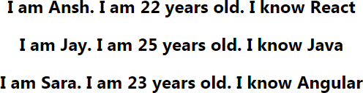

1. WAP to implement a list of users that have pets using list rendering and key

Input: Const user = [ {Name:'chris', pets: [{name: 'bella', type: ’dog’},

{name: 'cocoa', type: ’dog’}]}, {Name:'nick',

pets: [{name: 'hilo', type: ’cat’}, {name: 'polly', type: ’cat’}]} ]; And output is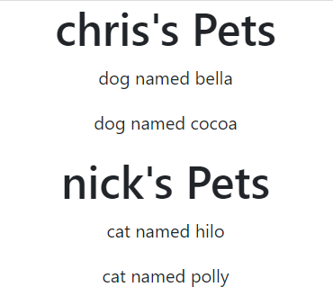

1. WAP to generate following output on button click , toggle design colors and effect using CSS Stylesheet and conditions



1. WAP to generate following output using inline css without use js object 
2. WAP to generate following output using CSS Module and on hover add zoom effect

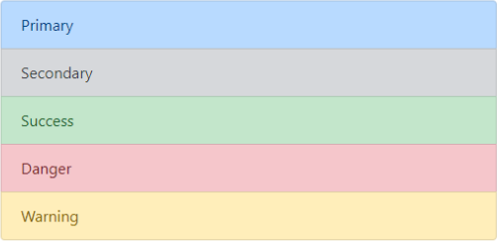

1. WAP to generate following output using inline css with use js object on js mouseover event change css color

